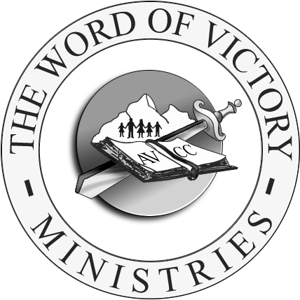
ANTELOPE VALLEY CHRISTIAN CENTER

EVENT PLANNING AND FACILITY USE REQUEST PACKET

INSTRUCTION COVER SHEET

The attached is to be completed for any AVCC related event which draws upon the financial, volunteer, facility and/or labor resources of the ministry. (IMPORTANT NOTE: You are still required to complete and submit an Event Planning and Facility Use Request Packet even when your event is to be held at an off-site location while still requiring the use of AVCC financial, volunteer, and/or labor resources.)

The following areas of consideration are listed within the Event Planning and Facility Use Request Packet.

✓ Applicant Information ✓ Event Planning
✓ Facility Use ✓ Catering/Food Service
✓ Event Advertisement/Graphics ✓ Volunteer Supportive Ministry (VSM) Support
✓ Media Support ✓ Ministerial Support
✓ Transportation Support ✓ Custodial Support
✓ Facility Set-up Diagram

Complete the areas within the Packet which relate to your event. The more thorough you are in completing this packet, the easier it will be to process and respond to your request. Also, to avoid unnecessary delays in processing your request packet, if there is a primary (1st choice) and secondary (2nd choice) date and location for your event, then please be sure to indicate such within the packet.

If your event requires a budget for the expenditure and/or reimbursement of funds, then it is your responsibility to complete a Material Requisition (MR) form and attach it to this packet. MRs can be found in the Forms Folders located next to the VSM Team Leader inboxes. (IMPORTANT NOTE: Expenditure reimbursement using AVCC finances will only be made when there is an approved MR in place. Therefore it is important for you to confirm MR approval before expending funds for which you would like to be reimbursed.)

Once you have completed the Event Planning and Facility Use Request Packet, you may submit it to the church office for processing. You will be contacted within 10 business days as to the status of your request.

